

Aman Kumar Dev

College id: 160255

[amonfromdharan@gmail.com](mailto:amonfromdharan@gmail.com)

submitted to: Manoj Shrestha

smart street light

Solution to electric wastage

**Statement of originality**

This is to confirm that the substance of this undertaking is my own work as far as I could possibly know. This undertaking has not been submitted for any degree or different purposes.

I affirm that the scholarly substance of this project is the result of my own work and that all the help got in setting up this venture and sources have been recognize.

Aman Kumar Dev

Softwarica College of IT and E-Commerce

Batch 19 B

Contents

Introduction 0

Aim 0

Objectives 0

Problem Statement 1

Segments used to develop smart street light. 3

How it works? 7

Circuit Diagram of the project 8

Sketch 9

Troubleshooting 11

Other application 11

Figure 1: Street light glowing whole night even it is not necessary. 2

Figure 2: Meeting to discuss to reduce electric wastage. 3

Figure 3: After installing street light to reduce electric wastage. 3

Figure 4: Arduino UNO 4

Figure 5: PIR sensor 5

Figure 6: Relay Module 5

Figure 7: Breadboard 6

Figure 8: Jumper Wire 7

Figure 9: example picture of PIR sensor sensing movement 8

Figure 10: implementing PIR sensor with Arduino UNO 9

Figure 11: Sketch of Smart Street Light 10

Figure 12:Sketch of Smart Street Light 11

# Introduction

Movement sensor distinguishing street light is trying to spare the superfluous utilization of power. As indicated by research and study, the vast majority of the power wastage is done by the streetlights. A large portion of the street lights sparkles entire night even it is not important, even there is nothing or nobody on the street. The vast majority of the street lights uses high watt halogen bulb which is a high-power utilization item and the utilization of power is expanding day by day. So as to spare and save vitality in an effective manner a power controller, based on movement detection is utilized. This is done by implementing a PIR sensor. At whatever point, if the PIR sensor distinguishes any movement, it sends an order to light to turn on using Arduino.

# Aim

The venture means to structure a prototype of programmed movement identifying street light which works utilizing PIR sensor to reduce unnecessary wastage of electricity.

# Objectives

* Comprehend pervasive computing and its application.
* Get familiar with the idea of detecting the warm body using PIR sensor.
* Research on the comparative project.
* Research on use of electricity and its wastage.

# Problem Statement

As appeared in the below given pictures, figure number one is demonstrating the issue of not executing smart street light. The street lights are sparkling entire night even it isn't important which is driving towards electric wastage. The expansion of electric wastage can expand the assessment installment for the natives of any nation which will unevenness the monetary state of any individual.

Presently, as appeared in figure number two and three, after some examination and meeting to figure out how to spare electric vitality, the execution of smart street light which identifies movement is done. After the usage of smart street light, presently the utilization of power is decreased. Presently the light shines only if there is a movement close to the sensor and turns itself off naturally after couple of minutes. The season of street light to turn off could be set manually. Presently this procedure of usage of street light could diminish immense measure of electric wastage.

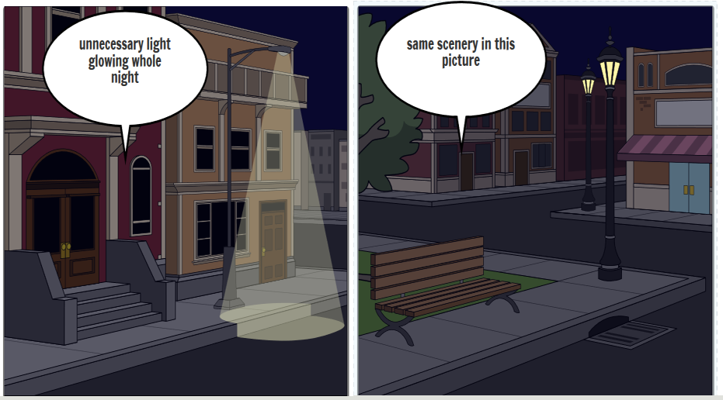

Figure 1: Street light glowing whole night even it is not necessary.

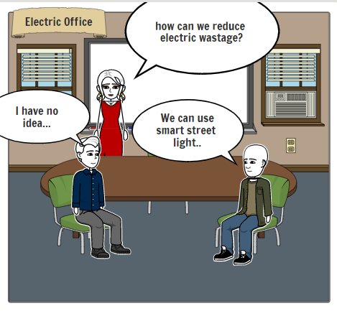

Figure 2: Meeting to discuss to reduce electric wastage.

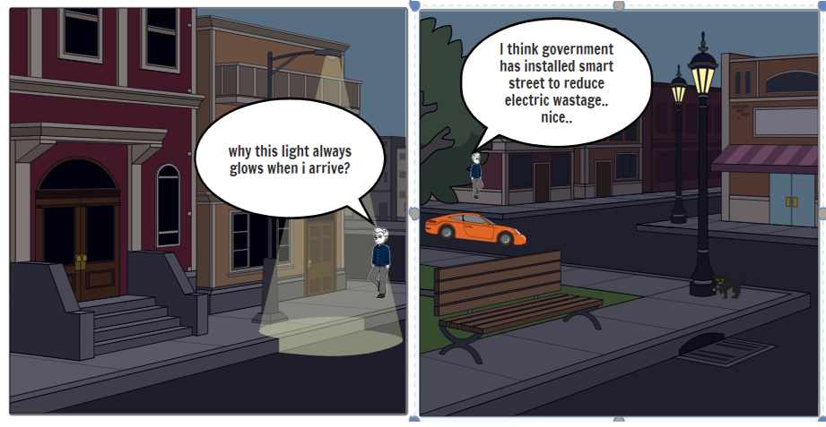

Figure 3: After installing street light to reduce electric wastage.

# Segments used to develop smart street light.

The task utilizes parts, for example, Arduino UNO as a PC that can be customized to control unlimited gadgets and manifestations, jumper wire to associate various pins, breadboard to interface and collect jumper wire of various associated gadget, Relay module to control one electrical circuit by opening and shutting contacts in another circuit, PIR sensor to identify the development of the close-by zone and to send the got information to Arduino UNO, power supply to let the light sparkle if necessary. amassing every one of these things together and applying the required code in Arduino UNO board, the smart street light is developed.

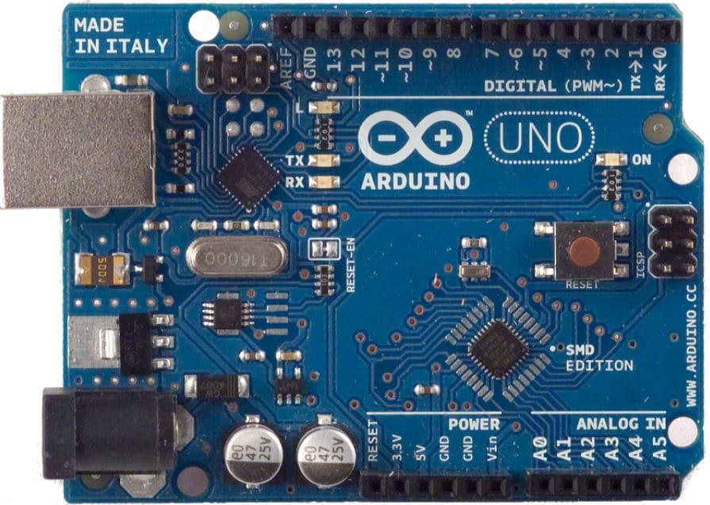

Figure 4: Arduino UNO

Arduino is an open source device for structure devices schemes. Arduino includes both physical programmable circuit panel (regularly referred to as a micro-controller) and little bit of programming, or Integrated Development Environment that keeps running on the computer, used to compose and transfer PC code to the physical board.

The Arduino phase has come out to be a very famous with any persons simply beginning with devices, and in light of present conditions. Unlike most of the programming circuit boards, Arduino does not need a changed bit of gear. So, in order to load new code in the Arduino board, a USB link could be essentially utilized. Furthermore, Arduino IDE uses a rearranged rendition of C++, making it simpler to figure out how to program. Arduino gives a typical standard designed factor which breakdowns the elements of the small-scale controller into a progressively open package.

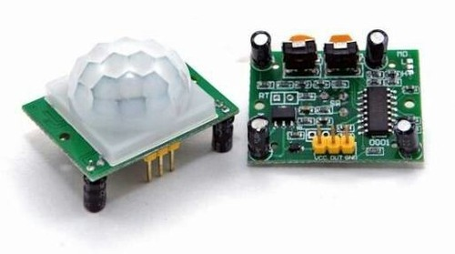

Figure 5: PIR sensor

(Passive Infrared sensor) A gadget used to recognize movement by accepting infrared radiation. At the point when an individual stroll past the sensor, it recognizes a quick difference in infrared vitality and sends a sign. PIR sensors are utilized for applications, for example, consequently turning on lights when somebody goes into a room or making a camcorder start working.

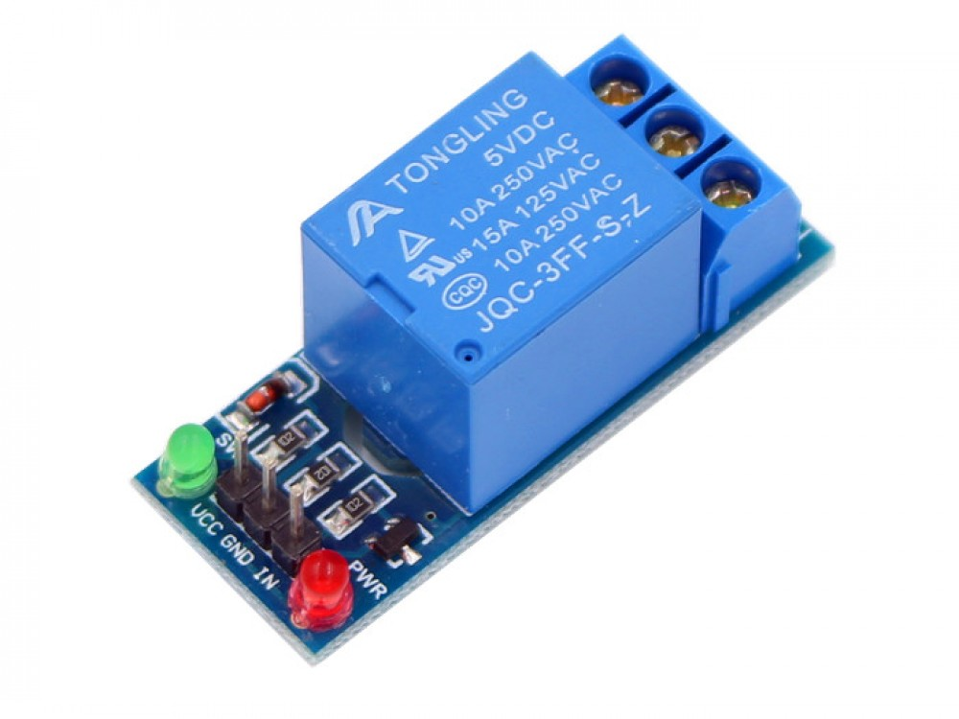

Figure 6: Relay Module

Relay Modules are one kind of switch which opens and closes the circuits electromagnetically or electronically. Relay control one electrical circuit by opening and closing contacts in another circuit. As the diagram of Relay Modules shows, when a relay contact is normally open (NO), there is an open contact when the relay is not stimulated.

Relays are generally used to switch slighter flows in a control circuit and don't for the most part control devouring devices aside from little engines and Solenoids that draw low amps. In any case, relay can control bigger voltages and amperes by having an enhancing impact in light of the fact that a little voltage connected to a relay’s curl can result in a huge voltage being exchanged by the contacts.

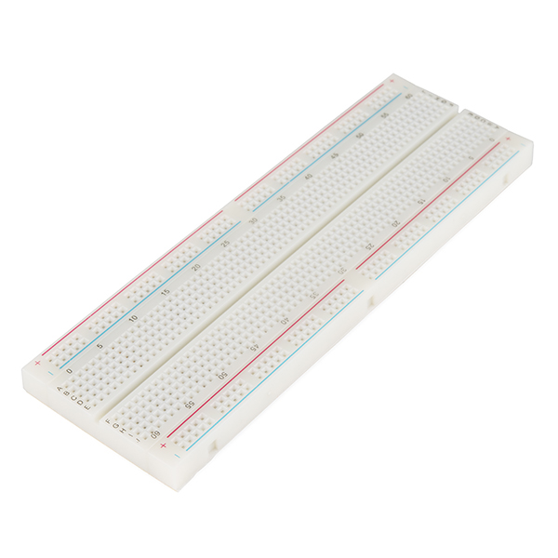

Figure 7: Breadboard

A flimsy white plastic board which is used to hold electronic parts (chips, transistors, resistors, and so on.) that are connected with each other using wires. Breadboard is commonly used to develop any required models of electronic circuits. Breadboard can always be reprocessed for any other occupations in the future. It can be utilized to design one of a kind system.

The breadboard contains spring cut contacts normally prepared in networks with specific squares of clips officially wired with each other. The segments and jumper wires are linked to the clips to develop the design of the circuits.

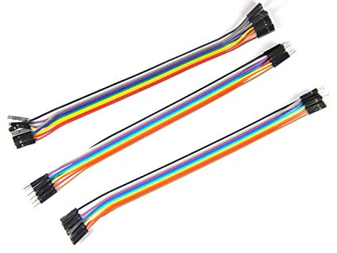

Figure 8: Jumper Wire

A jumper wire is a leading wire used to exchange electrical flag between two points of circuits. The wires can either be utilized to alter circuits or to analyze issues inside a circuit.

Jumper wires regularly vary in shading and size contingent upon what they are being utilized for. In breadboards, Jumper wires are utilized to build up associations between the focal miniaturized scale controller and different gadgets, for example, catches and sensors.

In the event that conceivable, the jumper wire ought to dependably be set on the segment side of a circuit board. The wires ought to likewise be directed in a X-Y way, maintaining a strategic distance from any curves. Jumper wires ought to never be raised more then 8 inch above the surface of the circuit board.

# How it works?

Smart street light contains a sensor named PIR sensor. PIR sensor detects warm body nearby itself. It takes the movement as an information and sends that information to PC (Arduino UNO for now) where required code is implemented inside. At whatever point any warm body like human's body or any animal’s body goes by the sensor it sends information to the Arduino UNO and the pre implemented C++ code executes and directions the light to sparkle. Furthermore, after couple of minutes (time set in Arduino utilizing C++ code) the light turns off naturally. This procedure keeps running as long as Arduino and the light gets power supply. Smart street light senses warm body in the zone of ten meters. This is the way of running of smart street light utilizing various sorts of segments assembled together and directed by a PC for example Arduino UNO.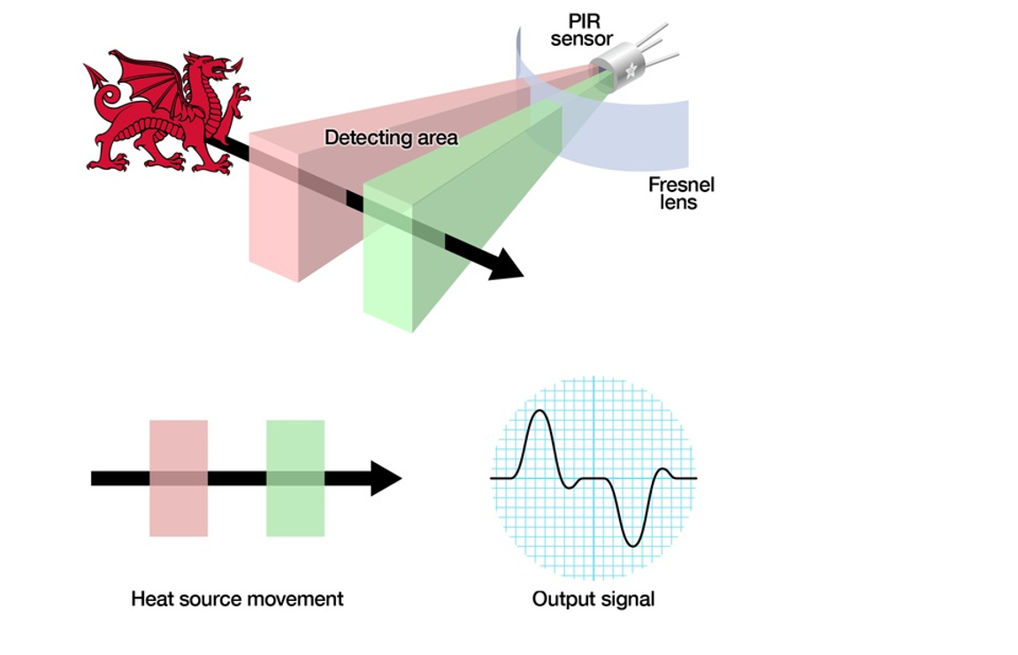

Figure 9: example picture of PIR sensor sensing movement

# Circuit Diagram of the project

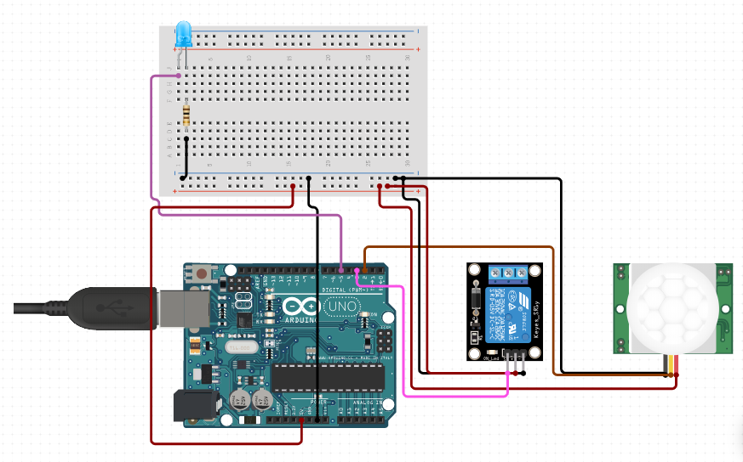

Figure 10: implementing PIR sensor with Arduino UNO

Steps to develop Smart Street Light: - (not using bulb)

* Connect Arduino with computer using USB cable.
* Connect Arduino’s 5 volt to the positive circuit of the breadboard.
* Connect Arduino’s GND to the negative circuit of the breadboard.
* Connect Arduino’s pin 8 to PIR sensors out pin.
* Connect PIR sensor’s GND to breadboard’s GND line i.e. Negative line.
* Connect PIR sensor’s VCC to breadboards 5v line i.e. Positive line.
* Connect PIR sensor’s OUT In Arduino’s 2
* Connect Relay’s GND to breadboard’s GND line.
* Connect Relay’s VCC to breadboard’s VCC line.
* Connect Relay’s IN1 to Arduino’s pin 3.
* Connect LED’s positive to Arduino’s pin 5.
* Connect LED’s negative to breadboard’s negative line using a resistor.

In the wake of doing every one of these means, Arduino Integrated development environment (IDE) ought to be opened and the required C++ code must be assembled and transferred in Arduino UNO. Presently Smart Street Light is prepared to utilize.

# Sketch

The following is the sketch of Smart Street Light so as to run the product.

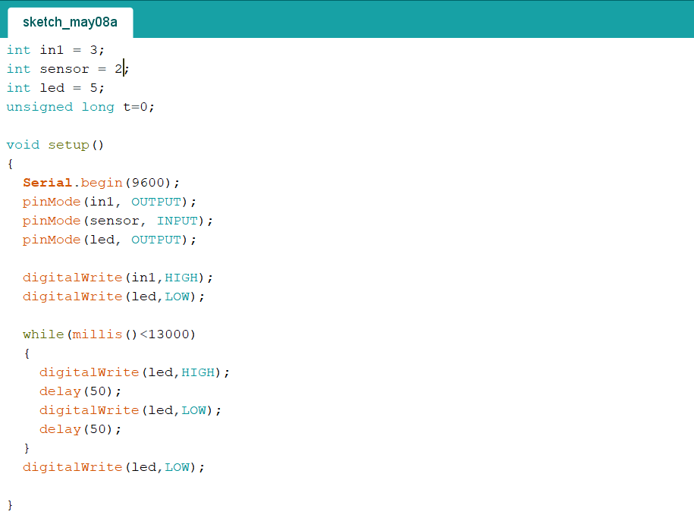

Figure 11: Sketch of Smart Street Light

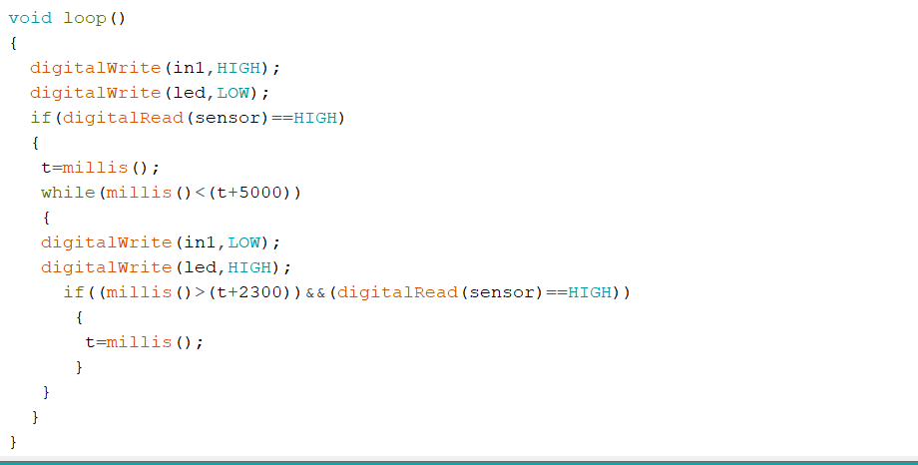

Figure 12:Sketch of Smart Street Light

# 

# Troubleshooting

During the time spent making the task of smart street light, the issue was the PIR sensor used to detect all the warm body movements around 10 meters. Little movements close to the sensor could turn on the light and I was confounded whether the executed code is running consummately or not. At that point I took the task to an unfilled room and endeavored to run the venture in that room. The light was gleaming as long as I was moving inside the room. At that point I went outside the room and sat tight for couple of minutes, the light was naturally turned off. Once more, I went into the room and the light detected my warm body and began to shine. In this way, the issue was fathomed.

# Other application

There are numerous different parts where smart street light could be actualized. For instance: -

* Hospitals
* Industries
* Office
* Public places

# References

Circuito.io. (2019). *How to wire Basic Ultraviolet LED 5mm, Infrared PIR Motion Sensor Module, Relay Module to Arduino Uno*. [online] Available at: https://www.circuito.io/app?components=512,8662,11021,931983,3061987 [Accessed 17 May 2019].

Galco.com. (2019). *How Relays Work | Relay diagrams, relay definitions and relay types*. [online] Available at: https://www.galco.com/comp/prod/relay.htm [Accessed 14 May 2019].

Pcmag.com. (2019). *PIR sensor Definition from PC Magazine Encyclopedia*. [online] Available at: https://www.pcmag.com/encyclopedia/term/60092/pir-sensor [Accessed 16 May 2019].

Reference. (2019). *What Is a Jumper Wire?*. [online] Available at: https://www.reference.com/technology/jumper-wire-893b2d7c5b8f447d [Accessed 13 May 2019].